**Code :**

LIBRARY IEEE;

USE IEEE.STD_LOGIC_1164.ALL;

USE IEEE.STD_LOGIC_ARITH.ALL;

USE IEEE.STD_LOGIC_UNSIGNED.ALL;

Port ( a : in STD_LOGIC_VECTOR (3 downto 0);

b : in STD_LOGIC_VECTOR (3 downto 0);

sel : in STD_LOGIC_VECTOR (2 downto 0);

y : out STD_LOGIC_VECTOR (3 downto 0));

end ALUBATCH;

architecture Behavioral of ALUBATCH is

begin

process(a, b, sel)

begin

case sel is

when "000" => y <= a + b;

when "001" => y <= a - b;

when "010" => y <= a AND b;

when "011" => y <= a OR b;

when "100" => y <= a XOR b;

when "101" => y <= a XNOR b;

when "111" => y <= a;

when others => y <= "0000";

end case;

end process;

end Behavioral;

**RTL Diagram :**

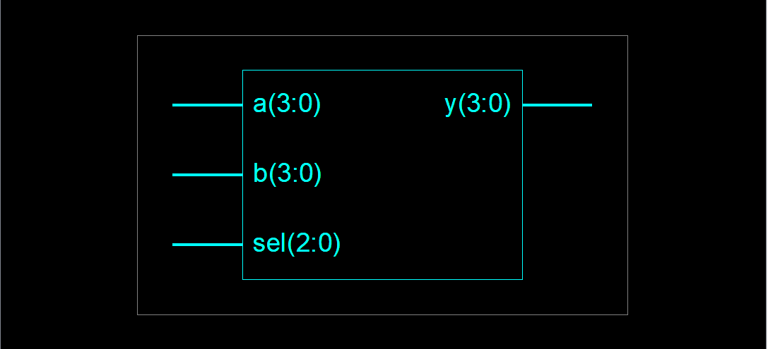

**Output :**

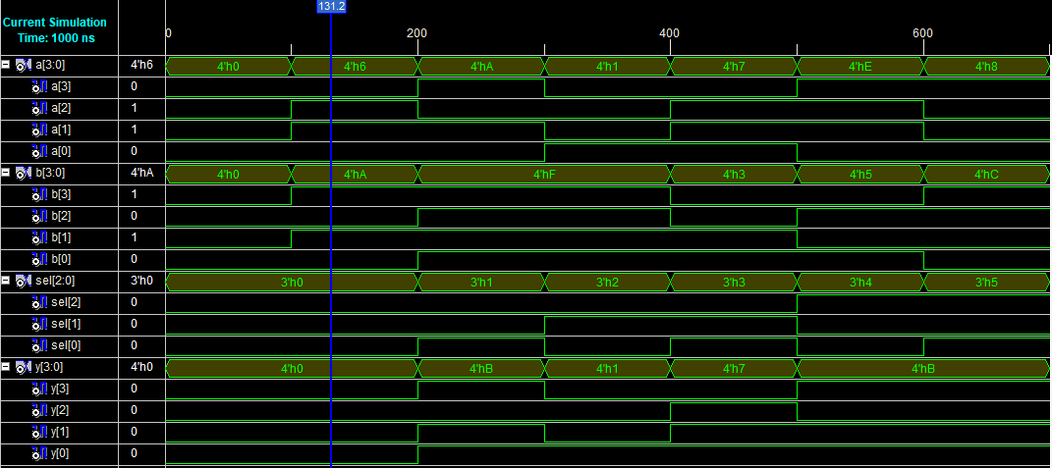

**Pin Assignment :**

| **I/O Name** | **I/O Direction** | **Loc** | **Bank** |
| --- | --- | --- | --- |
| a[0] | Input | P206 | BANK0 |
| a[1] | Input | P205 | BANK0 |
| a[2] | Input | P203 | BANK0 |
| a[3] | Input | P200 | BANK0 |
| b[0] | Input | P192 | BANK0 |
| b[1] | Input | P193 | BANK0 |
| b[2] | Input | P189 | BANK0 |
| b[3] | Input | P190 | BANK0 |
| sel<0> | Input | P179 | BANK0 |
| sel<1> | Input | P180 | BANK0 |
| sel<2> | Input | P165 | BANK0 |
| sel<3> | Input | P167 | BANK0 |
| y<0> | Output | P164 | BANK0 |
| y<1> | Output | P163 | BANK0 |
| y<2> | Output | P162 | BANK0 |